Lab Report 1- Chapter 1 (HTML and CSS)
Lab Report Format:
Instructions:
∙ Create your new repository on GitHub and push your lab solution to GitHub with new branch for each lab set.
∙ Share your repository to instructor.basanta@gmail.com as a collaborator. ∙ Print and attach your updated GitHub screenshot into lab set
Format
● Cover (Print)
● GitHub Screenshot
● Lab Question –hand written
● Introduction –hand written
● Syntax and Format –hand written (Includes tags, attributes and css properties in details)
● Code –hand written
● Output(Print)- With full URL- Your name must be shown into URL or into Github URL.
Please complete following lab task and prepare lab report accordingly.
1. Design 5 page layout using any of mockup tools (Figma, Balsamiq, Canva). 2. Create Basic HTML page structure for both HTML 4 and HTML 5. 3. Create an HTML home page with navigation links (About Us, Services, Gallery, and
Contact Us), each linking to separate content sections or pages. Use appropriate HTML tags (<a>, <section>, <div>, etc.) to structure the layout, ensuring each section includes relevant information (e.g., descriptions for "About Us," service details for "Services," images for "Gallery," and a form for "Contact Us"). Implement basic styling using CSS for better presentation and ensure the page is responsive on mobile devices. Test and validate the HTML to ensure proper functionality of the links and content display.
4. Write HTML code to display following lists
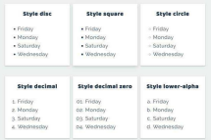
5. Write HTML code to create a webpage, which display following nested lists
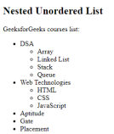 | 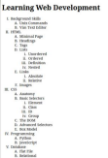

6. Write HTML code to display text formatting tags like
(b,strong,I,em,q,blockquote,del,ins,font,pre,code,tt,html entities,sub,sup). 7. Write HTML & CSS to display list faculties (Management, Science, Humanities) and program within those faculties available into TU.
8. Write HTML code demonstrate Image map with rectangle,circle and polygon shape. 9. Write HTML code to display your class routine into web page using table with various table attributes.
10. Write HTML and CSS code to display following table
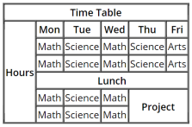
11. Write HTML code to display following output using frameset.
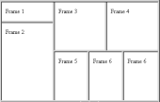 | 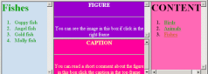

12. What is CSS? Write code to demonstrate types of CSS.
13. Write HTML code to display image gallery using HTML and CSS.
14. Write HTML and CSS code to display your CV into webpage.
15. Write HTML and CSS code to display following menu/navbar.
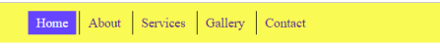16. Write HTML and CSS program to display dropdown menu.
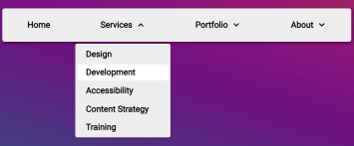
17. Write HTML and CSS code to display following responsive menu.
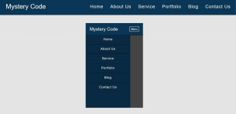
18. Write HTML and CSS code to display following form.
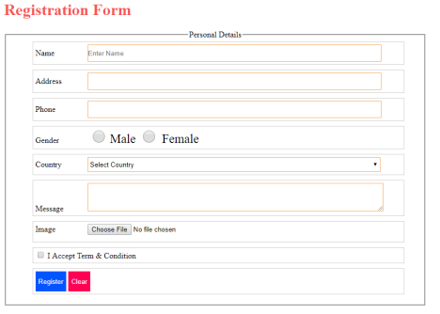19. Write HTML and CSS code to display following login and registration form.
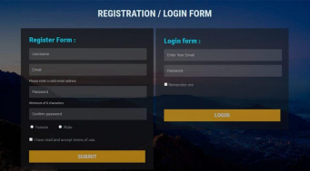
20. Design following layout using HTML and CSS (div based design)
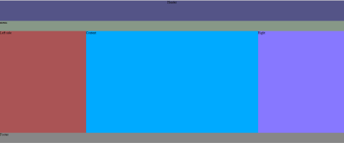Layout 1
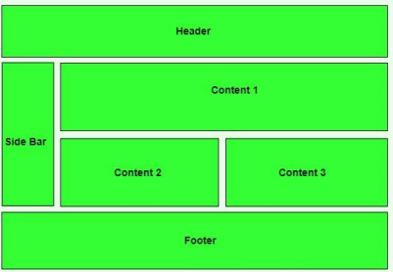Layout 2
21. Write HTML & CSS code to create user registration form for lok sewa aayog.
22. Write HTML and CSS code to display following responsive layout. 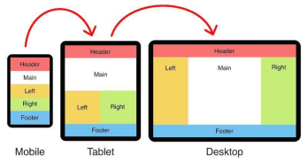23. Write HTML & CSS code to display your 2nd semester grade sheet .
24. Write HTML and CSS code to display following image overlay example (Show second design when user hover mouse on first image)
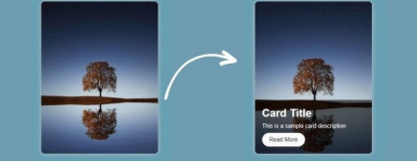
25. Write HTML and CSS code to design following card layout for team list
26. Write HTML and CSS code to create following image gallery (use your own image set)
27. Write HTML & CSS code to create following invoice
For each questions, please follow the following format
Q. Write HTML code to create basic web page structure
Introduction:
HTML: HTML is ………………………………………..
Tags & Attribute:
<html> :
<body>
<head>
<title>
<h1>
Code:
HTML (filename.html)
CSS(filename.css)
Output-printed

